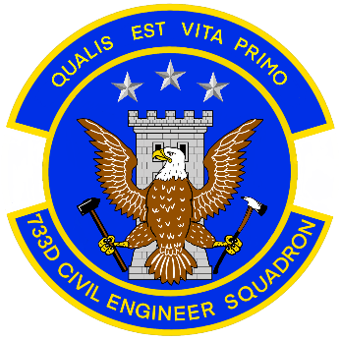**733d**

**Civil Engineer Squadron**

**Joint Base Langley Eustis**

**Request for Temporary Space Heater**

Name of Requestor: Telephone:

Building number and street:

Organization:

Name of Supervisor: Telephone:

Brief justification of need for heater:

Signature of requestor: ____________________________________________ Date:

Signature of immediate supervisor: __________________________________ Date:

Procedure for approval to use portable heaters.

Fill out form, sign and then scan and email to:

Engineering Flight Energy Manager

[733MSG.CEN.COMMUNITYPLANNING@us.af.mil](mailto:733MSG.CEN.COMMUNITYPLANNING@us.af.mil)

**DO NOT EMAIL PII or Encrypt this request, Energy Manger will request additional information if required.**

Based on approval by 733 CES/CEN Energy Manager, it will be signed and dated and a copy returned to the requestor & 733 CES/CEO Flight Chief.

Requestor will need contact the JBLE-Eustis Fire Department to request approval of type of heater. Keith Boyd, Assistant Chief of Fire Prevention 878-0227

The Fire Department **must** approve and tag the heater before it is used.

733CES/CEN Energy Manager signature: ____________________________________

Date: ____________ Approve_______ Disapprove_______

Use of portable electric space heaters in the workplace must be approved by 733 CES. Approval is not granted unless there is a condition warranting the need for portable heaters such as a written physician-documented medical condition of an employee. The approval is only good for 6 months or end of heating season, whichever comes first. A new request must be submitted each year prior to the heating season. Personnel working in facilities with fully operational heating systems are not normally authorized use of portable heaters.

Space heaters not permitted in most work areas, dress in layers

DAFMAN 91-203:

6.2.7. Space Heaters.

6.2.7.1. Use Nationally Recognized Testing Laboratory (NRTL)-listed or host nation

equivalent space heaters equipped with automatic shutoff devices that will shut off the

heater if it tips over. Space heaters shall also have an overheat protection device, an

automatic thermostat control and must be disconnected when not in use.

**Note:** Space heaters shall not be used without the approval of the installation energy manager.

Refer to the installation energy management program for additional local guidance. For a current list of OSHA-recognized NRTLs, visit

**https://www.osha.gov/dts/otpca/nrtl/nrtllist.html**

6.2.7.2. Plug space heaters directly into a wall receptacle. Do not plug space heaters into

extension cords or multiple outlet strips.

6.2.7.3. Maintain a 36-inch minimum distance or in accordance with manufacturer’s

instructions between any space heater and combustibles.

**Note:** The more restrictive of the guidance will apply.

6.2.7.4. Do not leave these devices unattended when in use and unplug them at the end of

the day or shift.

6.2.7.5. The use of space heaters in any hazardous location as defined by NFPA 70,

*National Electric Code,* is prohibited.